KSVB -

Functionality
Cost distribution is used to allocate primary costs from cost centers to other receivers in Controlling.

Scenario
This transaction is used to distribute planned non-labor costs from 5217000 to R&T orders.

Requirements
Statistical key figures have been entered for productive and non productive hours (RTHP01 and RTHN01).

Menu Path | Accounting → Controlling → Cost Center Accounting → Planning → Allocations → KSVB - Distribution
Transaction Code | KSVB

1. Double Click on KSVB - Distribution

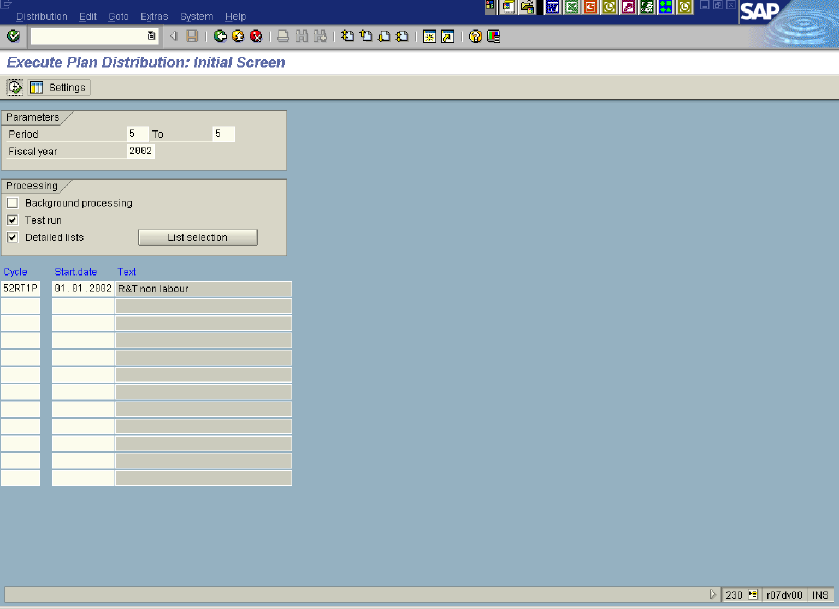
2. Press [F4] or Click the Search button in the Cycle field, the system will default cycle 52RT1P and start date 01.01.2002.
3. Click Test run .
4. Click Execute .

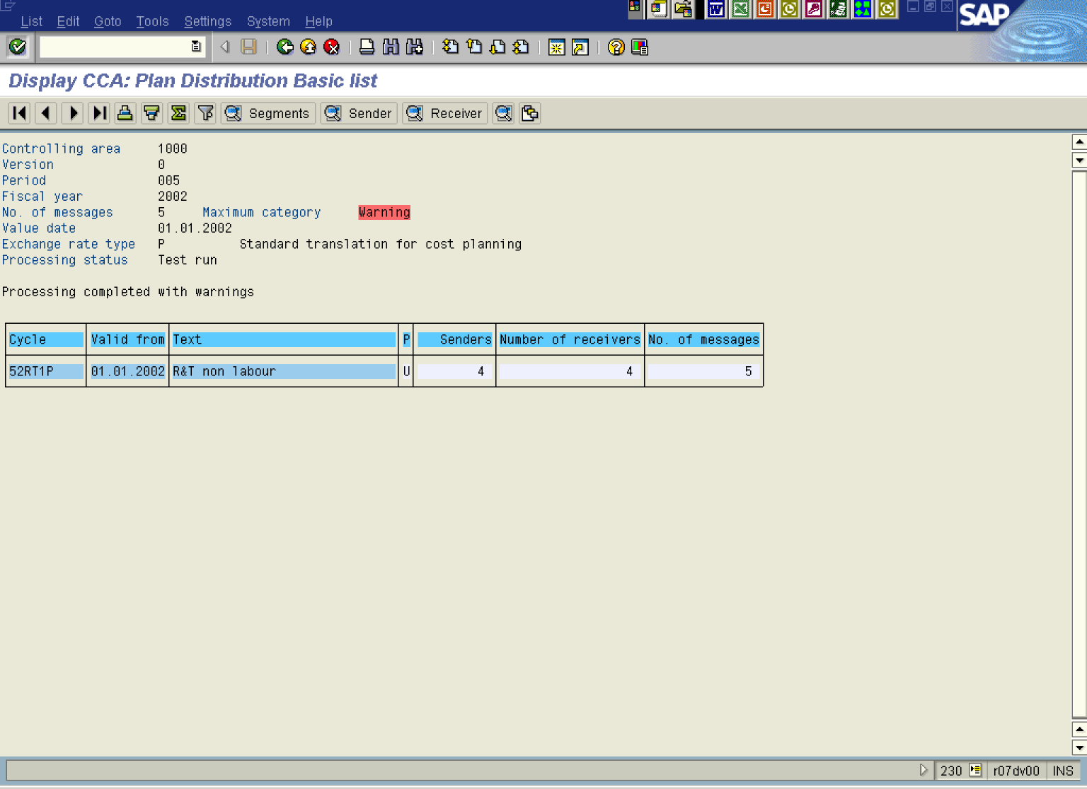

5. The system displays a list of planned non-labor costs distributed from 5217000 to R&T orders. Clicking on Senders you will notice that

